Car Rental Management System (CRMS)
Senior project
By:
Bereket Dress
In partial fulfillment of the requirement for the award of BS in Computer Science degree.
Instructor: Obina Kalu

June 14, 2026, Maharishi international University
Contents
1. Introduction 3
1.1 Problem Statement 4
2. Use Case Diagram 5
3. User Stories 5
3.1 Customer Stories 5
4. Staff Stories 5
5. Manager Stories 6
6. Acceptance Criteria 6
7. Main Scenarios (Basic Flow) 7
8. Class model diagram 8
9. Sequence diagram 10
10. Architecture type 10
Overall Workflow 11
11. Entity relationship Diagram 12
12. Logical Database Design 14
12.1 Core entities 14
13. User Interface 14
14. Containerization 15
15. Test 16
16. Conclusion 16
17. List of technologies used and their purpose 17

Introduction
The way companies run their day-to-day operations has changed a lot because of how fast technology is improving. This has led to things being done more efficiently, accurately, and in a way that makes customers happier. In the business of renting out vehicles, doing things manually - like handling bookings, keeping track of customers, taking payments, and managing the fleet - often causes delays, inconsistencies in data, and inefficiencies in how things are run. To deal with these issues, companies are increasingly using management systems that are accessed through the web. These systems automate how businesses work and provide a central place where all information can be found.
This project is about creating a Car Rental Management System, which is a web-based application. It's designed to make managing car rentals easier. The system has different user roles, like customers, staff, and managers, each with their own tasks and permissions. Customers can sign up, look for available cars, book a car, and see their rental history. Staff and managers can oversee the rental process, keep track of cars, handle payments, and make reports. The system aims to support multiple branches and users, making it a comprehensive tool for car rental businesses. It streamlines various operations, including customer management, vehicle inventory, reservations, and payments, all in one place.
The app is built using a modern tech stack, with React.js, JavaScript, and Tailwind CSS handling the frontend, Spring Boot, Spring MVC, Spring Data JPA, and Hibernate taking care of the backend. PostgreSQL is used to manage the database. The system also uses Stripe API to process online payments securely, showing how third-party services can be used in big applications. This setup allows for a strong and flexible foundation, making it easier to develop and maintain the app.
The system is designed with a three-tier architecture, which means it's divided into three main layers: presentation, business logic, and data access. This helps make the system easier to maintain, more modular, and scalable. To build a robust and maintainable solution, the project uses various software engineering principles. For instance, it uses object-oriented design to organize the code, UML modeling to visualize the system's structure, and database normalization to ensure the data is consistent and efficient. Additionally, the system uses RESTful communication to enable smooth interaction between different components. By following these principles, the system can provide reliable and efficient experience. The three-tier architecture and software engineering principles work together to improve the overall performance and maintainability of the system.
The objective of this project is to provide a reliable and efficient platform that automates car rental operations, reduces manual effort, minimizes booking errors, and improves the overall user experience while serving as a practical demonstration of modern software development techniques.

Problem Statement
DriveEasy Rentals operates a network of car rental branches across multiple city locations. Each branch has a name, phone number, and address, employs one or more staff members, and each branch has one Manager. Currently, vehicle availability, customer registrations, check-outs, check-ins, and payments are managed manually using paper records and spreadsheets, causing double bookings, inaccurate records, and delayed customer service. A centralized web-based system is needed to automate and streamline all rental operations across all branches.
The system retains information on all registered customers, including their name, phone number, address, driver's license number, and outstanding balance. Customers may search for available vehicles by type and make or cancel reservations. No customer with an outstanding balance is permitted to make a new reservation. All vehicles in the system are uniquely identified by their VIN (vehicle identification number). Each vehicle records its brand, plate number, model, year, mileage, daily rate, and availability status, and is classified under a car type such as Sedan, SUV, Van, or Truck. Daily rates are set individually by vehicle, allowing flexible pricing across the inventory. Vehicles are assigned to branches, and their availability can be checked at any time.
A registered customer may make zero or more reservations. Each reservation may include one or more vehicles and specifies a pickup date. Staff members may confirm or cancel reservations, and a confirmed reservation may be converted into one or more rentals when the customer picks up the reserved vehicles.
Only staff members are authorized to perform check-out and check-in operations. During check-out, staff record the checkout date and the vehicle's starting mileage. During check-in, staff record the return date, ending mileage, and any damage identified on the vehicle. Each rental stores the checkout date, return date, start mileage, end mileage, and rental status.
Every rental is settled by exactly one payment, which records the payment amount, payment method, and payment date. Rental fees are calculated based on the number of rental days multiplied by the vehicle's daily rate, plus any Damage repair costs. Any damage identified during check-in is recorded in a damage report containing its description, repair cost, and status.
Managers are responsible for managing vehicles and staff within their branch and may view operational reports to monitor reservations, rentals, payments, and vehicle usage. Each manager has a name, phone number, and email address.

Use Case Diagram
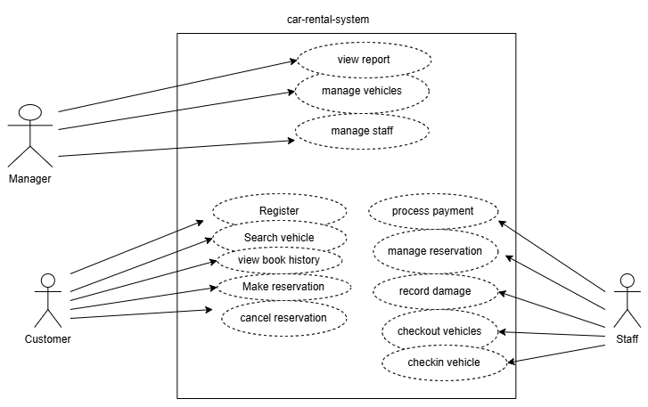

User Stories

Customer Stories
- As a customer, I want to register, so I can use the system.
- As a customer, I want to search for available vehicles, so I can choose a car.
- As a customer, I want to make a reservation by selecting a vehicle and pickup date, so I can secure my booking.
- As a customer, I want to cancel my reservation, so I can change my plans.
- As a customer, I want to view my booking history, so I can track my reservations and rentals.

Staff Stories
- As a staff member, I want to confirm or cancel reservations, so I can manage bookings.
- As a staff member, I want to check out a vehicle, so I can hand it over to a customer.
- As a staff member, I want to record the starting mileage during check-out, so the rental begins with accurate information.
- As a staff member, I want to check in a returned vehicle, so I can complete the rental process.
- As a staff member, I want to record the ending mileage and any vehicle damage during check-in, so rental charges can be calculated correctly.
- As a staff member, I want to process payments, so the rent can be settled.

Manager Stories
- As a manager, I want to manage vehicles, so I can maintain inventory data.
- As a manager, I want to manage staff, so I can maintain employee information.
- As a manager, I want to view operational reports, so I can monitor reservations, rentals, payments, and vehicle usage.

Acceptance Criteria
This section defines the acceptance tests for each functional requirement. These tests are used to verify that the final implementation meets the specified user stories and business requirements before the system is accepted.
User Story 1: Vehicle Reservation
Story: As a customer, I want to reserve a vehicle so that I can rent it.
- Given the customer is logged in and has no outstanding balance
- When the customer selects a vehicle, specifies a pickup date, and confirms the reservation
- Then the system verifies that the customer has no outstanding balance, creates the reservation with status “Pending”, and displays a confirmation message.
User Story 2: Vehicle Check-out
Story: As a staff member, I want to check out a vehicle so that I can hand it over to the customer.
- Given a valid confirmed reservation exists
- When the staff member records the checkout date and starting mileage
- Then the system creates a rental record, stores the checkout date and starting mileage, and updates the vehicle status to “Rented”.
User Story 3: Vehicle Check-in
Story: As a staff member, I want to check in a vehicle so that I can complete the rental.
- Given an active rental exists
- When the staff member records the return date, mileage ending, and any vehicle damage
- Then the system calculates the rental fee based on the rental duration and vehicle daily rate, adds any damage repair costs, creates the payment record, updates the vehicle status to “Available”, records any damage report, and marks the rental as “Completed”.

Main Scenarios (Basic Flow)
Scenario 1: Vehicle Reservation
- Customer logs into the system.
- Customer searches for available vehicles.
- System displays matching vehicles.
- Customer selects a vehicle and pickup date.
- System verifies that the customer has no outstanding balance.
- System checks vehicle availability.
- Reservation is created with status “Pending”.
- Confirmation is displayed to the customer.
Scenario 2: Vehicle Check-out
- Staff select a confirmed reservation.
- System verifies the reservation.
- Staff record the checkout date and starting mileage.
- System creates the rental record.
- Vehicle status is updated to “Rented”.
- Rental begins.
Scenario 3: Vehicle Check-in
- Staff selects an active rental.
- Staff record the return date, ending mileage, and any vehicle damage.
- System calculates the rental fee based on the number of rental days and the vehicle's daily rate, plus any damage repair costs.
- System creates the payment record.
- If damage exists, the system creates a damage report.
- Vehicle status is updated and becomes “Available”.
- Rental status is updated to “Completed”

Class model diagram
The Class Diagram is like a map for the Car Rental Management System. It shows all the main parts, like customers, vehicles, and staff, and how they work together. This diagram is important because it helps designers and builders create a clear plan for the system. It's a static picture that shows how all the different pieces fit together, making it easier to understand how the whole system works. By looking at the Class Diagram, you can see how customers make reservations, rent vehicles, and make payments, and how the staff helps with all these things. It's a guide for building the system, so everything runs smoothly and works well together.
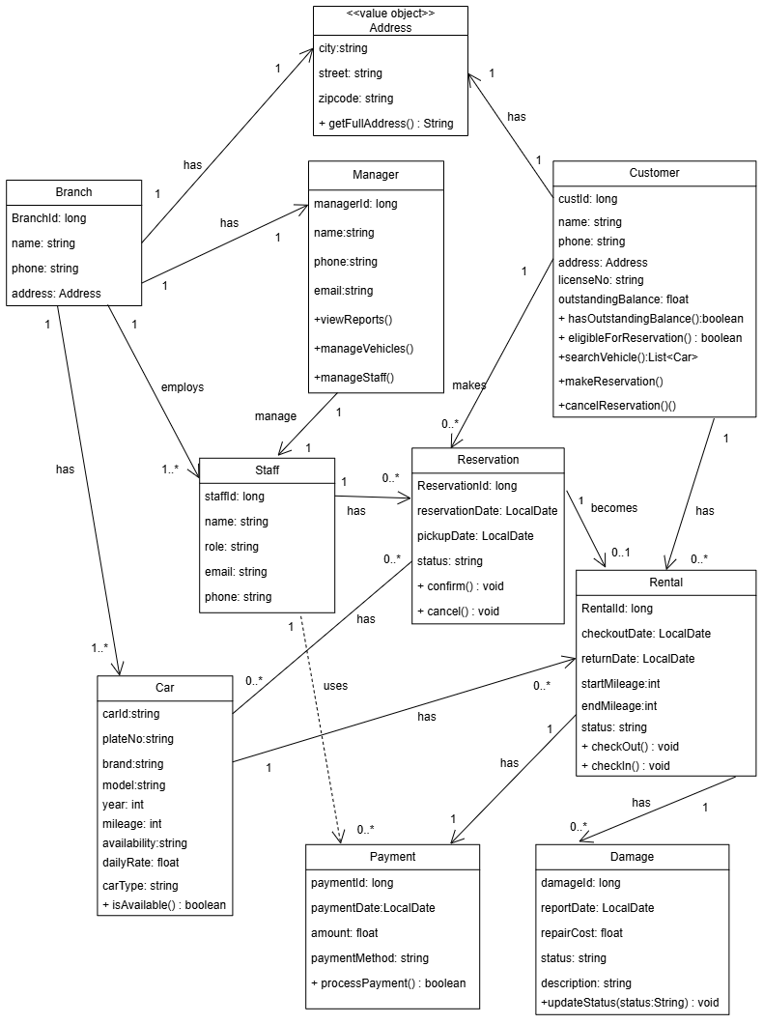

Sequence diagram
It is an example of a reservation sequence diagram in a layered monolithic system. This sequence diagram demonstrates a typical layered interaction pattern where the controller coordinates user requests, the service layer applies business logic, DAOs handle data persistence, and the database stores and retrieves information. The process ensures that customers can search for available vehicles, select one, create a reservation, and receive confirmation in a structured and organized manner.
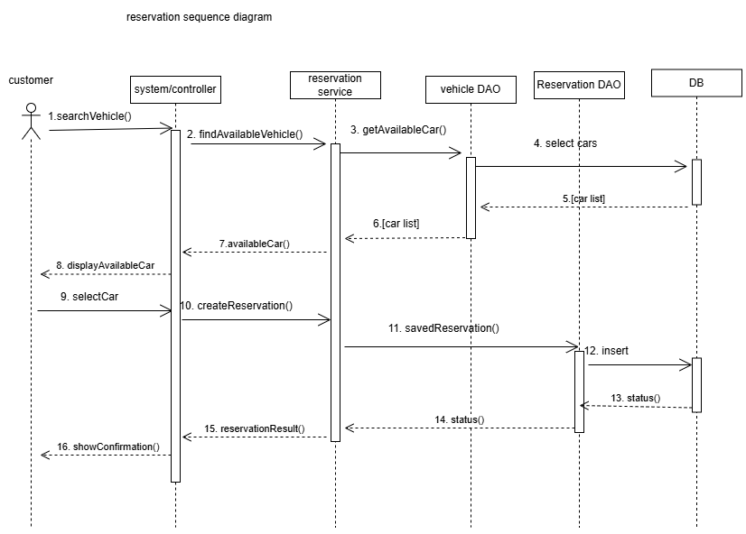

Architecture type
The Car Rental Management System follows a layered monolithic architecture with a clear separation of concerns into the presentation tier, controller/API tier, business service tier, data access tier, and data tier. The client-side front-end is implemented as a React (JavaScript) single page application, while the Backend is a single Spring Boot application that exposes RESTful APIs.
The backend organized into one module of different packages such as model, repository, service, controller, exception, security, config, DTO, and utility. The business logic contains Branch Service, Car Service, Customer Service, Damage Service, Manager Service, Payment Service, Rental Service, Reservation Service, Staff Service, and Stripe Integration Service. These services encapsulate the core functionality of the system and are invoked by REST controllers. Data persistence is handled through the Repository/DAO layer using Spring Data JPA and Hibernate, which interact with a shared PostgreSQL database. Although the application contains multiple domain-specific services, they are all packaged and deployed together as a single Spring Boot application rather than as independently deployed services. This design is good for small number of users.

Overall Workflow
- Users access the system through Customer Portal, Staff Portal, or Manager Portal using a web browser.
- The React (JavaScript) frontend sends HTTP REST requests to the Spring Boot backend.
- The appropriate REST controller receives each request and delegates it to the corresponding business service.
- The business service executes the required application logic, validations, and processing.
- The service interacts with the Repository/DAO layer to retrieve or update data stored in the PostgreSQL database.
- The Repository/DAO layer uses JPA/Hibernate to communicate with the database and return the requested data.
- The processed results are returned to the controller, which generates a REST response and sends it back to the frontend for display to the user.
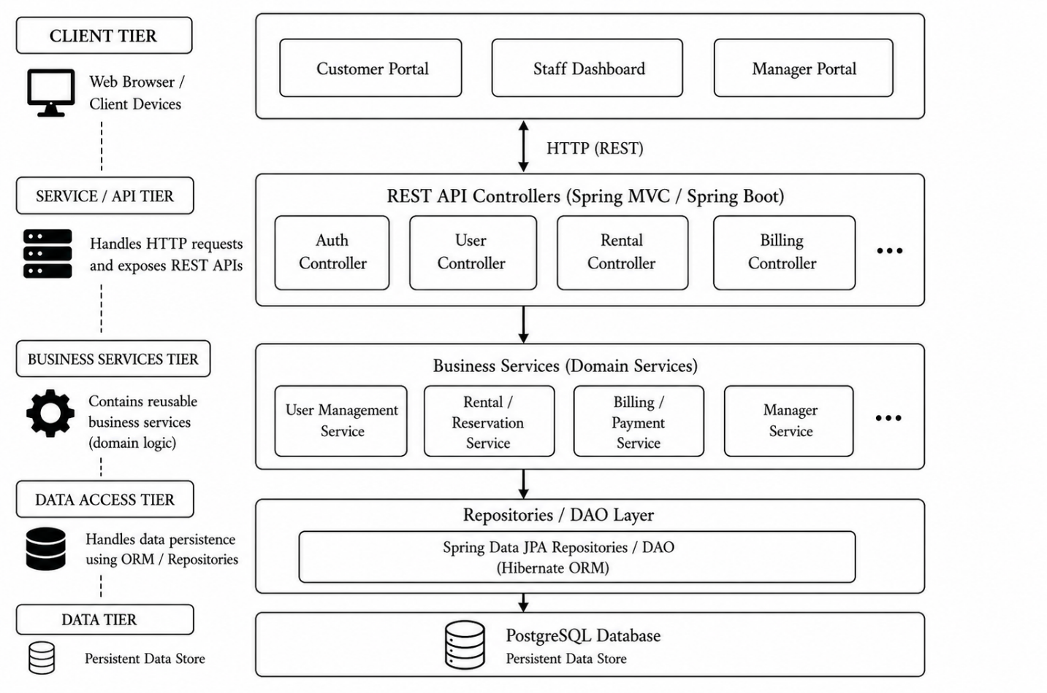

Entity relationship Diagram
The Entity Relationship (ER) Diagram models the data structure of the Car Rental Management System (CRMS) and illustrates how the main entities interact to support vehicle reservations, rentals, payments, and branch operations.
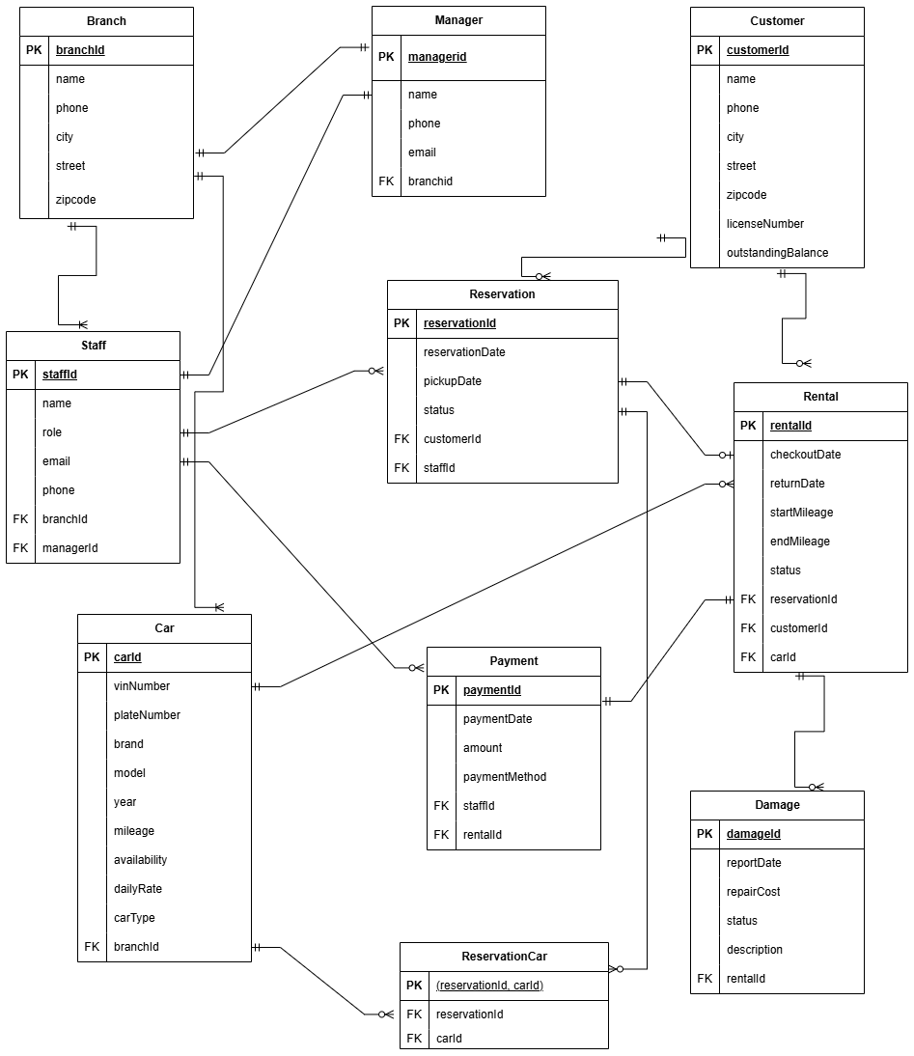

Logical Database Design

Core entities
Branch (branchId PK, name, phone, city, street, zipcode)
Manager (managerId PK, branchId FK, name, phone, email)
Staff (staffId PK, branchId FK, managerId FK, name, role, email, phone)
Customer (custId PK, name, phone, city, street, zipcode, licenseNumber, outstandingBalance)
Car (carId PK, branchId FK, plateNumber, brand, model, year, mileage, availability, dailyRate, carType)
Reservation (reservationId PK, customerId FK, staffId FK, reservationDate, pickupDate, status)
ReservationCar (reservationId FK, carId FK, PRIMARY KEY (reservationId, carId))
Rental (rentalId PK, reservationId FK, customerId FK, carId FK, checkoutDate, returnDate, startMileage, endMileage, status)
Payment (paymentId PK, staffId FK, rentalId FK, paymentDate, amount, paymentMethod)
Damage (damageId PK, rentalId FK, reportDate, repairCost, status, description)

User Interface
This section presents the user interface and illustrates the interaction functionalities available to customers, staff, and managers. Each actor can interact directly with the backend system through a web browser to perform the operations relevant to their role. The following screenshots demonstrate the interfaces and functionalities for each type of user.
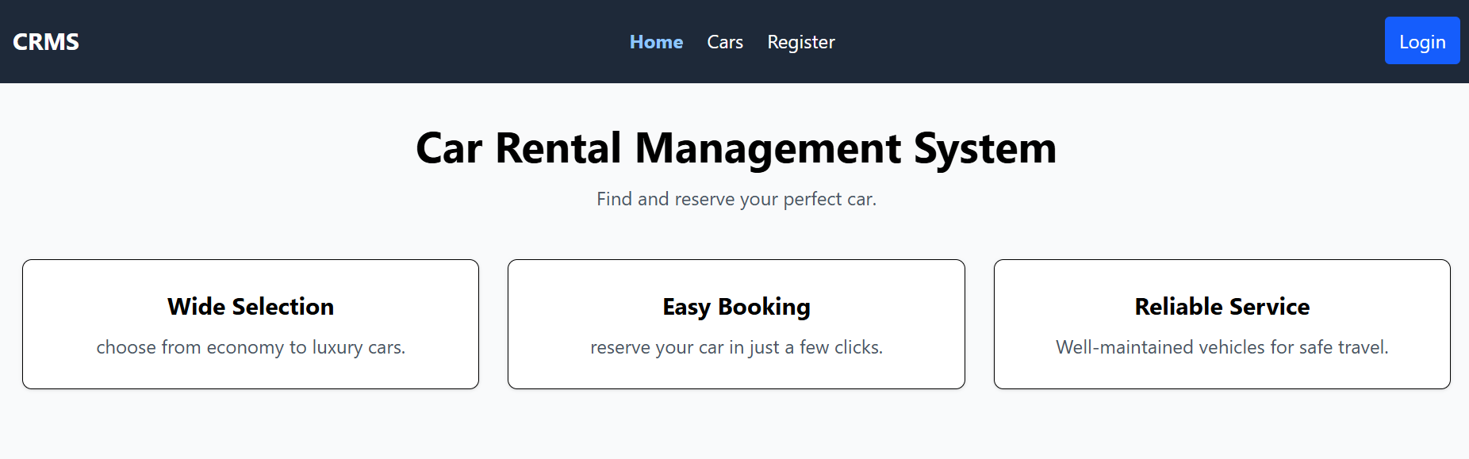
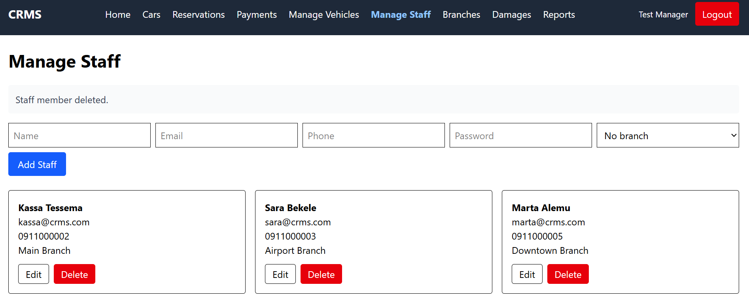

Containerization
The Car Rental Management System was containerized using Docker to improve portability, consistency, and ease of deployment as indicated below in the figure. By packaging the application and its dependencies into Docker containers, the system can run reliably across different environments without requiring manual installation or configuration of software components. Containerization also simplifies development and testing by ensuring that the frontend, backend, and database operate in isolated and reproducible environments. Additionally, using Docker Desktop enables the application to be managed, started, and stopped efficiently on a local machine, while providing a foundation for future deployment to cloud platforms or container orchestration tools such as Kubernetes.
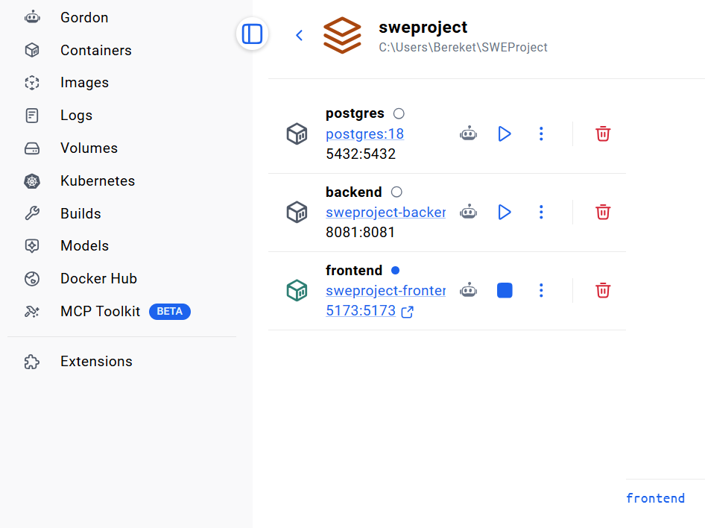

Test
The project includes built-in support for software testing through its Maven configuration. Specifically, the spring-boot-starter-test dependency provides a comprehensive testing framework that includes JUnit 5, Spring Test, Mockito, and other utilities for writing and executing unit and integration tests. These testing libraries enable verification of individual components, business logic, REST controllers, and interactions between application layers, thereby improving the reliability, maintainability, and overall quality of the Car Rental Management System.

Conclusion
The Car Rental Management System (CRMS) provides a comprehensive solution for automating the core operations of a multi-branch vehicle rental business. By replacing manual record-keeping and spreadsheet-based processes with a centralized web application, the system improves operational efficiency, minimizes booking errors, and enhances customer service.
The proposed solution supports essential business functions, including customer registration, vehicle search, reservation management, rental check-out and check-in, payment processing, damage reporting, and branch administration. The system follows a three-tier monolithic architecture with a clear separation between the presentation, business, and data access layers, making the application modular, maintainable, and scalable for future enhancements. The system also demonstrates integration with external services through the Stripe payment gateway, enabling secure and reliable online payment processing. This integration enhances the practicality of the application and reflects real-world enterprise software development practices. The class model, sequence diagram, service class diagram, entity relationship diagram, and logical database design collectively provide a solid foundation for implementation. These models demonstrate how different system components collaborate to satisfy user requirements while maintaining data integrity and business rules.
Overall, CRMS offers a reliable and organized platform for managing vehicle rental operations. Future improvements may include real-time notifications, GPS-based vehicle tracking, mobile applications, analytics dashboards, and migration to a microservices architecture if higher scalability and independent service deployment become necessary.

List of technologies used and their purpose
Spring Boot: Provides the backend framework, application configuration, dependency management, and embedded server for developing and running the web application
React.js: Builds an interactive and responsive user interface for customers and staff.
JavaScript: Provides dynamic functionality and interactivity for the frontend application.
Tailwind CSS: Styles the web application with a modern, responsive design.
Spring MVC (Spring Framework): Implements the backend controllers and business logic following the Model-View-Controller pattern.
Java: Primary programming language used to develop the backend services and business logic.
Hibernate: ORM Maps Java objects to relational database tables and simplifies database operations.
DAO/Repository Pattern: Encapsulates data access logic and separates persistence concerns from business logic.
JDBC: Enables communication between the Java application and the PostgreSQL database.
PostgreSQL: Stores persistent data such as customers, vehicles, reservations, rentals, payments, and damage reports.
HTTP/REST: Facilitates communication between the frontend client and the backend application server.
UML Diagrams: Used to model the system architecture, classes, interactions, and workflows during design.
stripe API: Processes secure online payments and integrate external payment functionality into the system.

